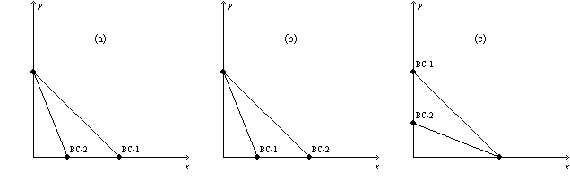
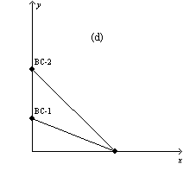
Problem 12. Figure 21-3
In each case, the budget constraint moves from BC-1 to BC-2.

a. Refer to Figure 21-3. Which of the graphs in the figure reflects a decrease in the price of good X only? Why?
b. Refer to Figure 21-3. Which of the graphs in the figure reflects an increase in the price of good X only? Why?
c. Refer to Figure 21-3. Which of the graphs in the figure reflects a decrease in the price of good Y only? Why?
d. Refer to Figure 21-3. Which of the graphs in the figure could reflect a simultaneous decrease in the prices of both goods? Why?
e. Refer to Figure 21-3. Which of the graphs in the figure could reflect a simultaneous decrease in the price of good X and increase in the price of good Y? Why?

